Press Release Template for Craft Spirits AwardsTM 2025 Winners
- Cut and paste this Press Release template to feature in social media, local, national and international press
- Add YOUR details to the [brackets] and delete red colour text before release
- Send to all your worldwide existing and potential suppliers, distributors, importers, press, social media and partners to share your news
[Name of Producer] [Owner of Brand or Spokesperson]
……………………………………………………………

A Toast to Triumph: [Name of Brand] Wins [Gold/Silver/Bronze] at Craft Spirits Awards™ 2025
A moment of pride for [Name of Brand]! Their dedication to excellence has been recognized with the [Gold/Silver/Bronze] Medal at the Craft Spirits Awards™ 2025, celebrating true craftsmanship in the World of Spirits.
Bringing together remarkable entries from around the globe, the Craft Spirits Awards™ shines spotlight on quality and authenticity. Each spirit is judged through the renowned Triple Blind Tasting™, ensuring every medal is earned purely on merit — a true reflection of craftsmanship and passion.
“We’re thrilled to be recognized at the Craft Spirits Awards™ 2025,” said [Name and title of company representative]. “Craft Spirits Awards™ Medal represents the heart of what we do — crafting spirits with care, creativity, and commitment to excellence.”
This year’s competition once again confirmed why the Craft Spirits Awards™ remains the trusted benchmark in the industry, inspiring producers worldwide to pursue innovation and artistry in every bottle.
Cheers to [Name of Brand] for this outstanding achievement at Craft Spirits Awards™ 2025!

Full results on:
https://craftspiritsawards.org/craft-spirits-awards-2025-result

Order official Medals Now:
(Digital Medals Delivered within 24 hours)
https://craftspiritsawards.org/sticker-shop/

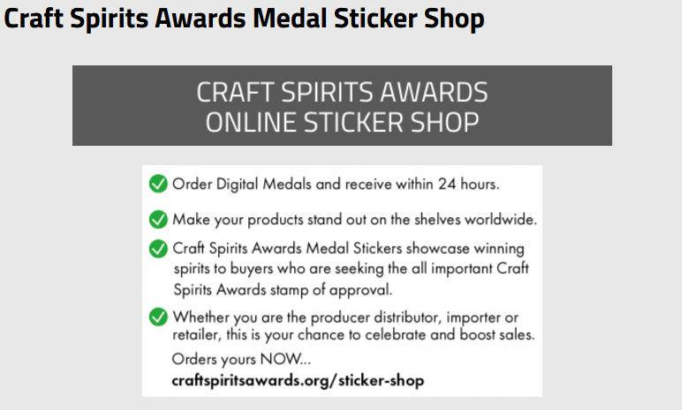

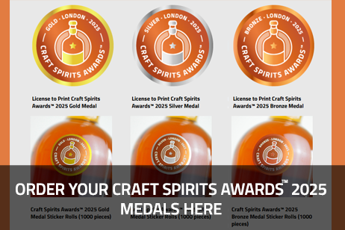
- Download Press Images at: https://craftspiritsawards.org/promote/

